Concrete CrewAI Folder Structure
Recommendation: use a Flow-first application with one focused prescription Crew. The Flow owns deterministic sequencing, typed state, guardrails, and human review; the Crew owns the GenAI analysis and recommendation. This follows CrewAI’s production guidance to start with a Flow, use structured state, and invoke focused Crews with explicit inputs. New CrewAI crew projects are JSON-first, with agent definitions in agents/*.jsonc and tasks/process settings in crew.jsonc.
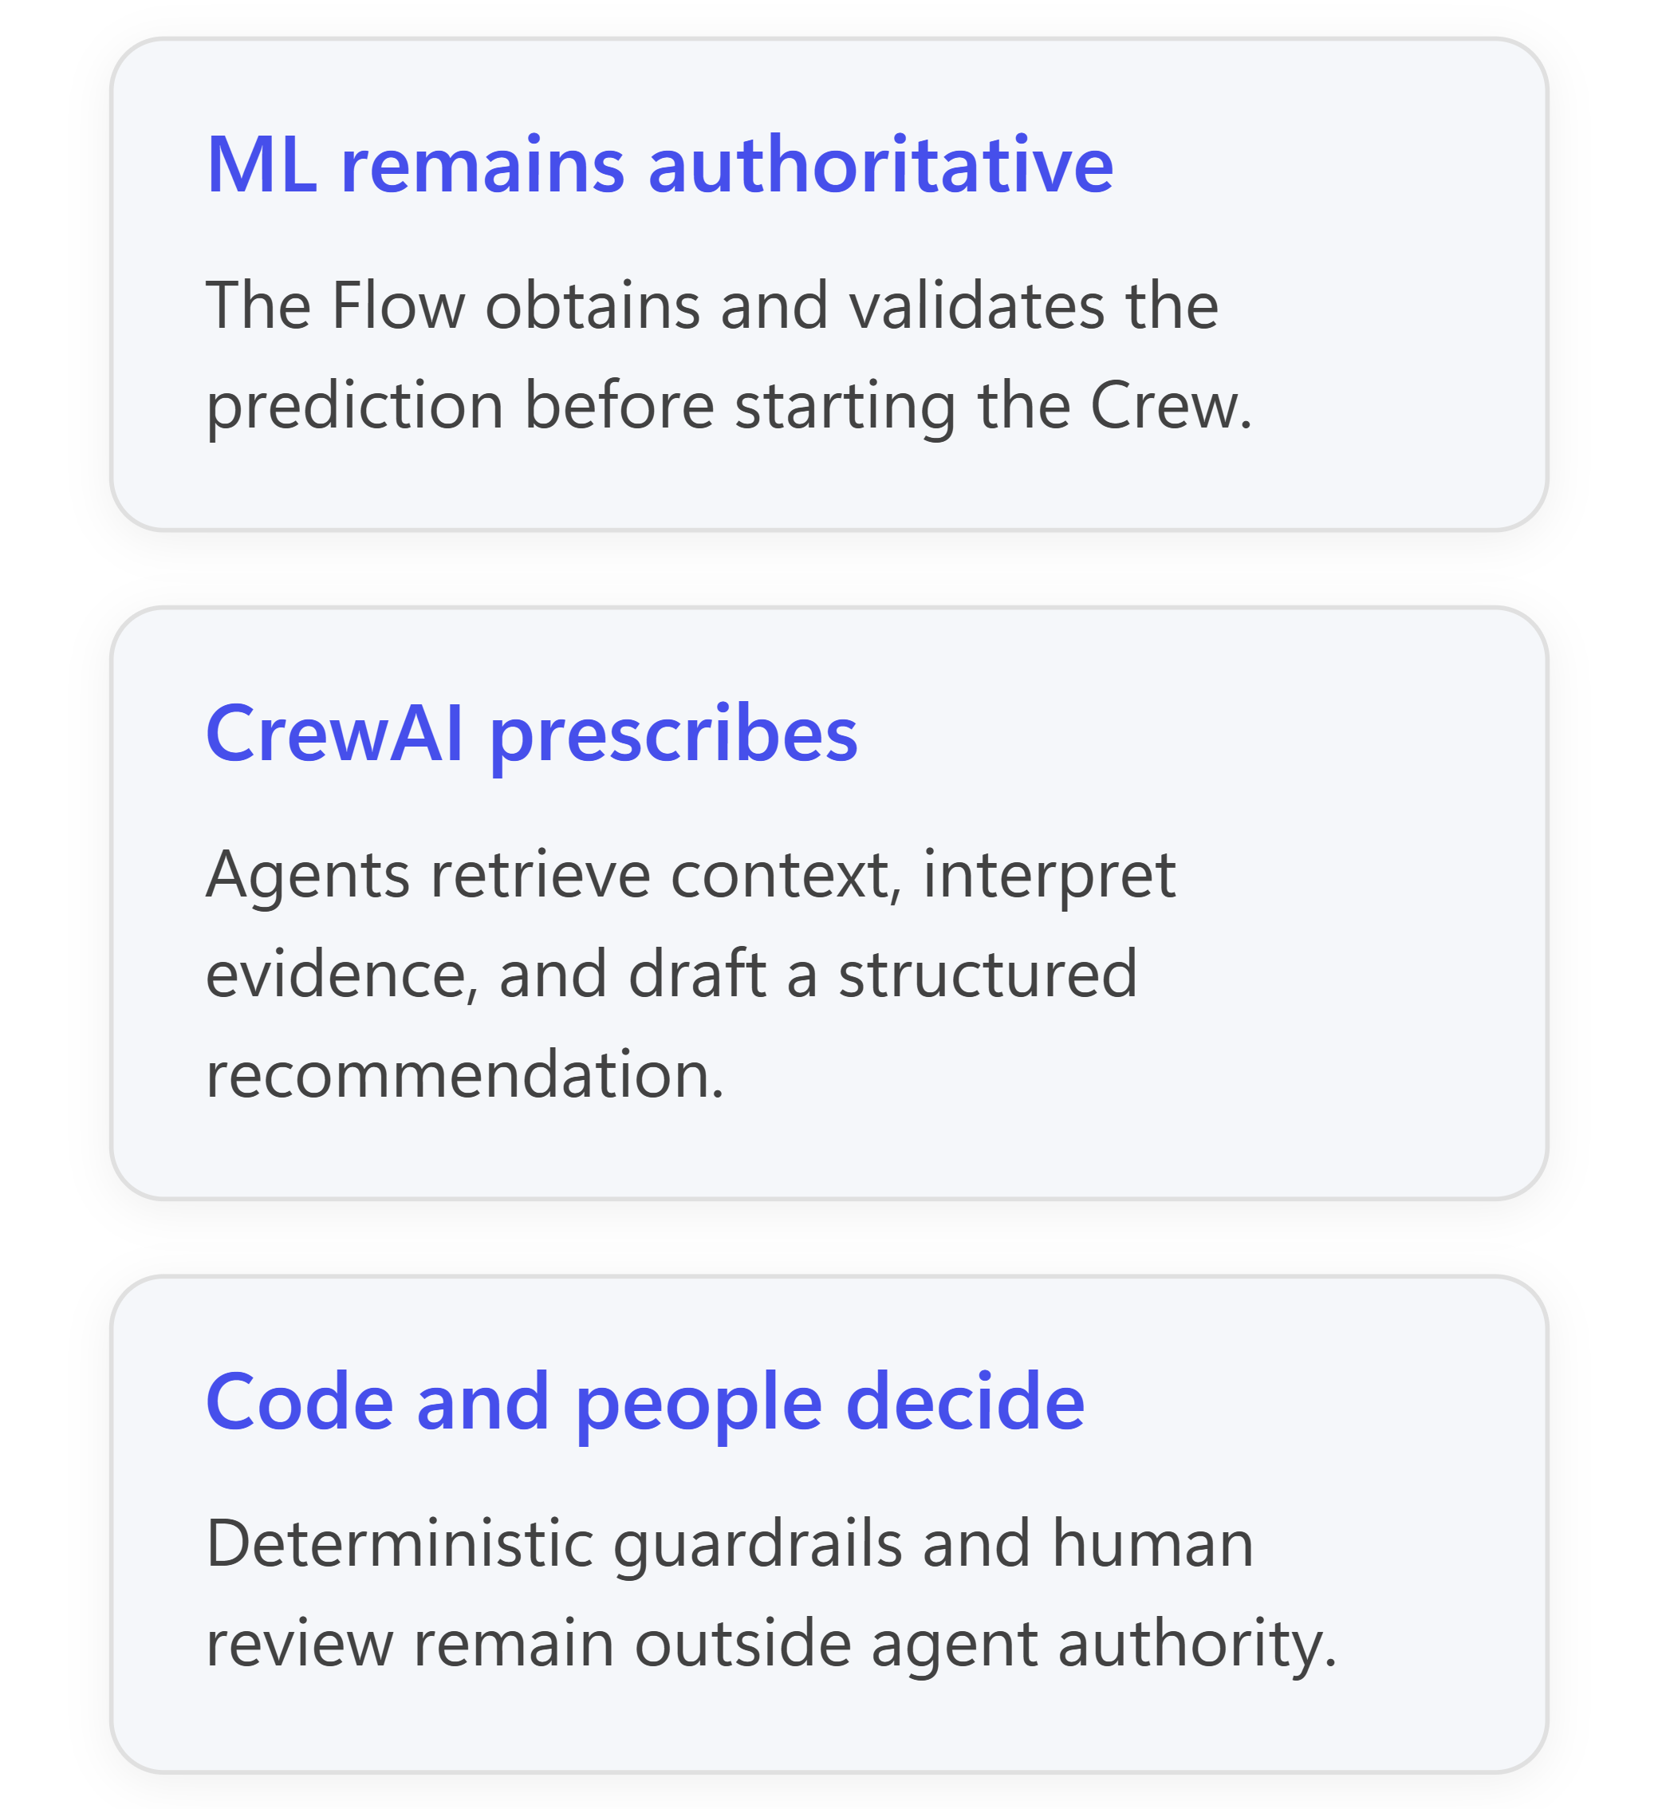
Your internal architecture work in Combining Machine Learning and Generative AI 2.docx already establishes the same boundary: CrewAI can coordinate, retrieve, explain, draft, and collect feedback, while model execution, policy decisions, authorization, and authoritative writes remain outside agent authority. It also calls for validating and preserving the prediction before the LLM sees it.

Recommended Full Folder Tree
1 D:\DevDrive\project-finance-ai\
2 │
3 ├── pyproject.toml # Python package and dependencies
4 ├── uv.lock # Locked dependency versions
5 ├── .env.example # Variable names only; no secrets
6 ├── .gitignore
7 ├── README.md
8 │
9 ├── configs\
10 │ ├── app.yaml # Thresholds, feature flags, paths
11 │ ├── providers.yaml # Logical provider selections
12 │ ├── logging.yaml
13 │ └── environments\
14 │ ├── development.yaml
15 │ ├── test.yaml
16 │ └── production.yaml
17 │
18 ├── data\
19 │ ├── raw\
20 │ │ └── tickets.csv # Training/source data
21 │ ├── processed\
22 │ │ └── .gitkeep
23 │ ├── feedback\
24 │ │ └── feedback.jsonl # MVP feedback store
25 │ └── evaluation\
26 │ ├── recommendation_cases.jsonl
27 │ └── expected_outcomes.jsonl
28 │
29 ├── artifacts\
30 │ ├── models\
31 │ │ └── ticket_escalation\
32 │ │ ├── model.joblib # Generated, not hand-edited
33 │ │ ├── metadata.json # Version, features, metrics
34 │ │ └── feature_schema.json
35 │ ├── runs\
36 │ │ └── .gitkeep
37 │ └── reports\
38 │ └── .gitkeep
39 │
40 ├── knowledge\ # CrewAI-compatible source root
41 │ ├── policies\
42 │ │ ├── escalation_policy.yaml
43 │ │ └── allowed_actions.yaml
44 │ ├── runbooks\
45 │ │ ├── vpn_incident.md
46 │ │ ├── authentication_failure.md
47 │ │ └── network_outage.md
48 │ └── catalog.yaml # IDs, versions, ownership
49 │
50 ├── src\
51 │ └── project_finance_ai\
52 │ ├── __init__.py
53 │ │
54 │ ├── contracts\ # Shared typed boundaries
55 │ │ ├── __init__.py
56 │ │ ├── ticket.py # TicketInput
57 │ │ ├── prediction.py # PredictionEnvelope
58 │ │ ├── evidence.py # EvidenceItem
59 │ │ ├── recommendation.py # Recommendation
60 │ │ ├── decision.py # HumanDecision
61 │ │ └── feedback.py # FeedbackRecord
62 │ │
63 │ ├── ml\ # PREDICT: no CrewAI logic
64 │ │ ├── __init__.py
65 │ │ ├── features.py # Feature preparation
66 │ │ ├── train.py # Offline model training
67 │ │ ├── evaluate.py # Accuracy/calibration metrics
68 │ │ ├── predictor.py # Loads model; returns envelope
69 │ │ └── model_registry.py # Resolves approved model version
70 │ │
71 │ ├── services\ # Framework-neutral domain services
72 │ │ ├── __init__.py
73 │ │ ├── prediction_service.py # Validates ML request/result
74 │ │ ├── knowledge_service.py # Retrieves runbook evidence
75 │ │ ├── policy_service.py # Returns applicable rules
76 │ │ ├── recommendation_service.py # Starts Flow
77 │ │ └── feedback_service.py # Records decision and outcome
78 │ │
79 │ ├── orchestration\
80 │ │ ├── __init__.py
81 │ │ │
82 │ │ ├── flows\
83 │ │ │ ├── __init__.py
84 │ │ │ ├── state.py # TicketDecisionState
85 │ │ │ └── ticket_decision_flow.py # Predict→Prescribe→Decide→Learn
86 │ │ │
87 │ │ └── crews\
88 │ │ └── ticket_prescription\
89 │ │ ├── agents\
90 │ │ │ ├── context_analyst.jsonc
91 │ │ │ └── recommendation_writer.jsonc
92 │ │ ├── crew.jsonc # Tasks, order, process, inputs
93 │ │ ├── loader.py # Loads crew and injects tools
94 │ │ └── schemas.py # Crew output schemas
95 │ │
96 │ ├── tools\
97 │ │ ├── __init__.py
98 │ │ ├── registry.py # Tool allowlist and construction
99 │ │ │
100 │ │ ├── custom\ # Your CrewAI BaseTool adapters
101 │ │ │ ├── __init__.py
102 │ │ │ ├── ml_prediction_tool.py
103 │ │ │ ├── prediction_lookup_tool.py
104 │ │ │ ├── knowledge_retrieval_tool.py
105 │ │ │ ├── policy_lookup_tool.py
106 │ │ │ └── feedback_recording_tool.py
107 │ │ │
108 │ │ └── external\ # Third-party/prebuilt tool setup
109 │ │ ├── __init__.py
110 │ │ ├── crewai_tools_factory.py
111 │ │ └── README.md
112 │ │
113 │ ├── adapters\ # Replaceable provider integrations
114 │ │ ├── __init__.py
115 │ │ │
116 │ │ ├── llm\
117 │ │ │ ├── __init__.py
118 │ │ │ ├── base.py # Internal LLM interface
119 │ │ │ ├── crewai_factory.py # Creates configured CrewAI LLM
120 │ │ │ └── settings.py
121 │ │ │
122 │ │ ├── retrieval\
123 │ │ │ ├── __init__.py
124 │ │ │ ├── base.py
125 │ │ │ ├── local_files.py # MVP implementation
126 │ │ │ └── vector_store.py # Later provider implementation
127 │ │ │
128 │ │ ├── persistence\
129 │ │ │ ├── __init__.py
130 │ │ │ ├── base.py
131 │ │ │ ├── jsonl.py # MVP
132 │ │ │ └── sql.py # Later
133 │ │ │
134 │ │ └── vectorstores\ # OPTIONAL / later RAG
135 │ │ ├── __init__.py
136 │ │ ├── chroma.py
137 │ │ └── qdrant.py
138 │ │
139 │ ├── guardrails\ # DECIDE: deterministic controls
140 │ │ ├── __init__.py
141 │ │ ├── recommendation_schema.py
142 │ │ ├── allowed_action.py
143 │ │ ├── evidence_validator.py
144 │ │ ├── prediction_consistency.py
145 │ │ └── approval_policy.py
146 │ │
147 │ ├── feedback\ # LEARN: controlled collection
148 │ │ ├── __init__.py
149 │ │ ├── repository.py
150 │ │ ├── outcome_linker.py
151 │ │ └── evaluation_dataset.py
152 │ │
153 │ └── observability\ # OPTIONAL for initial MVP
154 │ ├── __init__.py
155 │ ├── logging.py
156 │ ├── metrics.py
157 │ ├── tracing.py
158 │ └── audit_events.py
159 │
160 ├── apps\
161 │ ├── api\
162 │ │ ├── __init__.py
163 │ │ ├── main.py # FastAPI entry point
164 │ │ ├── dependencies.py
165 │ │ └── routes\
166 │ │ ├── analyze_ticket.py
167 │ │ ├── submit_decision.py
168 │ │ └── record_outcome.py
169 │ │
170 │ └── reviewer_ui\
171 │ ├── app.py # Streamlit or equivalent
172 │ └── views\
173 │ └── ticket_review.py
174 │
175 ├── scripts\
176 │ ├── setup.ps1
177 │ ├── train_model.ps1
178 │ ├── run_api.ps1
179 │ ├── run_ui.ps1
180 │ └── evaluate.ps1
181 │
182 ├── tests\
183 │ ├── unit\
184 │ │ ├── ml\
185 │ │ ├── services\
186 │ │ ├── tools\
187 │ │ └── guardrails\
188 │ ├── contract\
189 │ │ ├── test_prediction_contract.py
190 │ │ └── test_recommendation_contract.py
191 │ ├── crews\
192 │ │ └── test_ticket_prescription_crew.py
193 │ ├── flows\
194 │ │ └── test_ticket_decision_flow.py
195 │ ├── integration\
196 │ │ └── test_analyze_ticket.py
197 │ ├── golden\
198 │ │ └── ticket_recommendation_cases.yaml
199 │ └── end_to_end\
200 │ └── test_human_review_cycle.py
201 │
202 ├── notebooks\ # OPTIONAL exploration only
203 │ ├── model_exploration.ipynb
204 │ └── recommendation_evaluation.ipynb
205 │
206 └── infra\ # OPTIONAL production deployment
207 ├── docker\
208 ├── migrations\
209 └── monitoring\
This extends CrewAI’s official Flow scaffold rather than treating a standalone Crew as the entire application. CrewAI’s current JSON-first convention keeps agent files under agents/ and the ordered task definitions in crew.jsonc; the root-level knowledge/ directory follows the documented location for file-based Knowledge sources. It also aligns with the broader repository separation already proposed in Combining Machine Learning and Generative AI 2.docx.
Important: there is deliberately no separate tasks.yaml in the recommended tree. That is the older “classic” CrewAI layout. For a new implementation, put the two prescription tasks in crew.jsonc; keep executable validation and business logic in ordinary Python modules.

Crew and Task Ownership

ticket_prescription\agents\context_analyst.jsonc
Owns interpretation of the supplied context:
- Reads the already-created PredictionEnvelope.
- Uses knowledge_retrieval_tool and policy_lookup_tool.
- Identifies evidence, uncertainty, and applicable policy.
- Must not modify the prediction or invent another score.

ticket_prescription\agents\recommendation_writer.jsonc
Owns recommendation composition:
- Consumes the context-analysis task output.
- Produces a typed Recommendation.
- Has no ML-training, database-write, or execution tools.
- Suggests only allowlisted actions such as monitor, gather_more_information, or route_for_review.

ticket_prescription\crew.jsonc
Contains two sequential tasks:
- analyze_ticket_context
- draft_recommendation
The second task names the first as context. CrewAI tasks support explicit task context, task-specific tools, human input, guardrails, and Pydantic/JSON output models. [docs.crewai.com], [docs.crewai.com]

How Data Moves Through the Structure

- API receives a ticket.
apps/api/routes/analyze_ticket.py validates it as TicketInput and starts TicketDecisionFlow.
- Flow performs Predict.
prediction_service.py calls ml/predictor.py. The scikit-learn pipeline performs the same preprocessing used during training and then calls the final estimator’s prediction interface.
- Flow freezes the prediction boundary.
The result becomes a PredictionEnvelope, for example:
- This object is placed in TicketDecisionState. The Crew receives it as read-only input; no agent is asked to calculate, “verify,” or reinterpret the probability.
- Flow performs Prescribe.
It loads ticket_prescription, passes the ticket and prediction explicitly, and allows the context agent to retrieve policy and runbook evidence. The recommendation task returns a typed Recommendation.
- Application performs Decide.
guardrails/ checks schema validity, allowed action, evidence IDs, prediction consistency, and approval requirements. CrewAI’s Flow HITL support can then pause for approve/reject/revise feedback, or the API can expose the pending item through reviewer_ui. [docs.crewai.com], [docs.crewai.com]
- Application performs Learn.
feedback_service.py records the prediction, recommendation, human decision, later actual outcome, and model/prompt versions. This data feeds offline ML evaluation and GenAI evaluation—it does not immediately retrain the model or silently update prompts. Your internal architecture already recommends separating authoritative model execution from agent behavior and using feedback for controlled evaluation.

Compatible Tools: Where They Live
CrewAI custom tools can be implemented by subclassing BaseTool or by using @tool. Typed Pydantic outputs are especially appropriate here because prediction scores, policy IDs, evidence IDs, and decision records have stable fields. [docs.crewai.com], [docs.crewai.com]
Tool | Location | Called by | Behavior
MLPredictionTool | tools/custom/ml_prediction_tool.py | Flow only in the primary path | Delegates to PredictionService; returns PredictionEnvelope
PredictionLookupTool | tools/custom/prediction_lookup_tool.py | Context agent, if needed | Reads an existing prediction by run ID; cannot recompute it
KnowledgeRetrievalTool | tools/custom/knowledge_retrieval_tool.py | Context analyst | Returns read-only runbook passages plus evidence IDs
PolicyLookupTool | tools/custom/policy_lookup_tool.py | Context analyst | Returns applicable thresholds, allowed actions, and review rules
FeedbackRecordingTool | tools/custom/feedback_recording_tool.py | Flow after review | Appends a validated feedback record; not exposed to recommendation agents
The distinction is important:
- tools/custom/ contains CrewAI-compatible wrappers around your own services.
- tools/external/ constructs prebuilt CrewAI or third-party tools.
- adapters/ contains provider SDK details, credentials, endpoints, vector databases, and persistence implementations.
- services/ contains the business capability independent of CrewAI.
This prevents business rules from becoming embedded in a provider SDK or in an agent prompt. Your internal architecture similarly classifies read-only and bounded-compute tools separately from consequential actions that require human approval.

Provider Isolation
Keep the Crew configuration provider-neutral:
1 configs/providers.yaml
2 │
3 ▼
4 adapters/llm/crewai_factory.py
5 │
6 ▼
7 CrewAI LLM instance
Agent configurations should reference a logical model setting rather than importing a provider client directly. CrewAI supports multiple LLM providers and configuration through environment variables or code, so the factory can translate your application setting into the selected CrewAI LLM without changing the Flow, Crew, or agents. [docs.crewai.com], [docs.crewai.com]
For the MVP:
- adapters/retrieval/local_files.py reads curated policies and runbooks.
- Do not add a vector database yet.
- Keep CrewAI Memory disabled initially.
- Use explicit state and evidence instead.
Later, vectorstores/chroma.py or qdrant.py can implement the same retrieval interface. CrewAI distinguishes Knowledge—reference material used during tasks—from Memory, which can preserve and recall information across executions. [docs.crewai.com], [docs.crewai.com]

Minimal “Create These Files First” Checklist

Phase 1 — Predict
- pyproject.toml
- .env.example
- data/raw/tickets.csv
- contracts/ticket.py
- contracts/prediction.py
- ml/features.py
- ml/train.py
- ml/predictor.py
- services/prediction_service.py
- tests/contract/test_prediction_contract.py

Phase 2 — Prescribe with CrewAI
- contracts/evidence.py
- contracts/recommendation.py
- knowledge/policies/escalation_policy.yaml
- knowledge/runbooks/vpn_incident.md
- services/knowledge_service.py
- services/policy_service.py
- tools/custom/knowledge_retrieval_tool.py
- tools/custom/policy_lookup_tool.py
- orchestration/crews/ticket_prescription/agents/context_analyst.jsonc
- orchestration/crews/ticket_prescription/agents/recommendation_writer.jsonc
- orchestration/crews/ticket_prescription/crew.jsonc
- orchestration/crews/ticket_prescription/loader.py

Phase 3 — Decide and Learn
- orchestration/flows/state.py
- orchestration/flows/ticket_decision_flow.py
- guardrails/allowed_action.py
- guardrails/prediction_consistency.py
- guardrails/evidence_validator.py
- contracts/decision.py
- contracts/feedback.py
- feedback/repository.py
- services/feedback_service.py
- apps/api/main.py
- apps/api/routes/analyze_ticket.py
- apps/api/routes/submit_decision.py
- apps/reviewer_ui/app.py
- tests/end_to_end/test_human_review_cycle.py

Add Later, Not in the First Vertical Slice
- Vector database and full RAG ingestion.
- CrewAI Memory and cross-run lesson retention.
- Multiple crews or hierarchical processes.
- Dedicated validation agent.
- Flow persistence beyond the MVP store.
- External ticketing-system writes.
- Distributed workers or event queues.
- Full tracing, token-cost dashboards, and drift monitoring.
- Automated retraining or model promotion.
The smallest useful implementation is therefore:
1 Ticket API
2 → deterministic scikit-learn prediction
3 → typed Flow state
4 → two-agent prescription Crew
5 → deterministic guardrails
6 → human review
7 → append-only feedback
That gives CrewAI a meaningful orchestration role without allowing it to replace the predictive model, policy engine, approval gate, or learning controls.

